Game Lab 8 Detecting A Tank Collision

We may mark each possible collision position with, for example, an integer value i.e. Collision Position.
For example, with a head on collision with one tank in trajectory 1 and another in trajectory 2
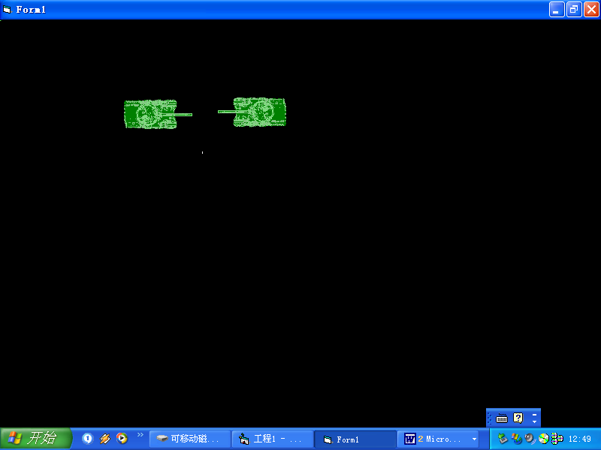

If the trajectory of Tank1 is right and trajectory of tank 2 is left Then
Mark the collision position as 1
End If

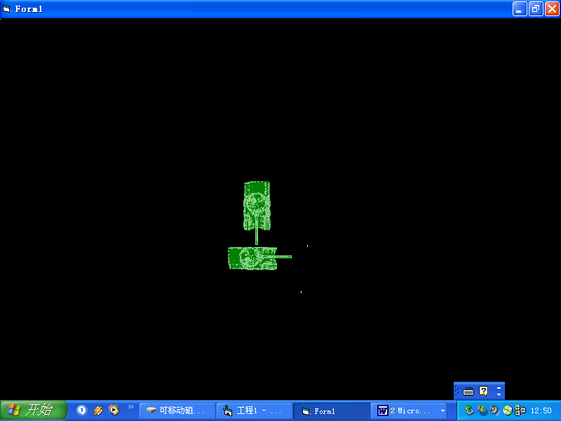
When coming down (or going up collision it does not matter in the other tank is in trajectory 1 (facing left) or trajectory2(facing right). The calculation will be the same.

If (P1 TRAJECTORY is down ) And ((P2 TRAJECTORY is left) Or (P2 TRAJECTORY is right)) Then
COLLPOS = 3
End If
….

‘Coming Up

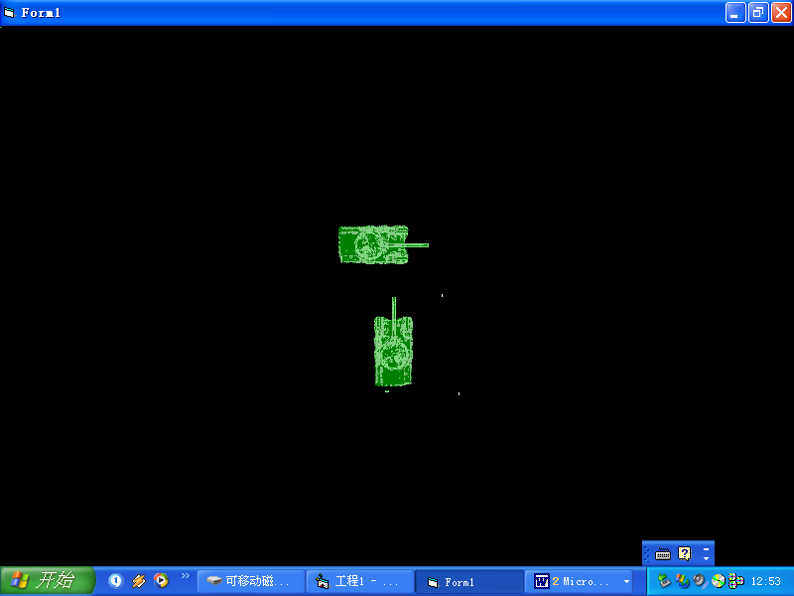

‘COMING ACROSS WITH BOTH FACING THE SAME WAY
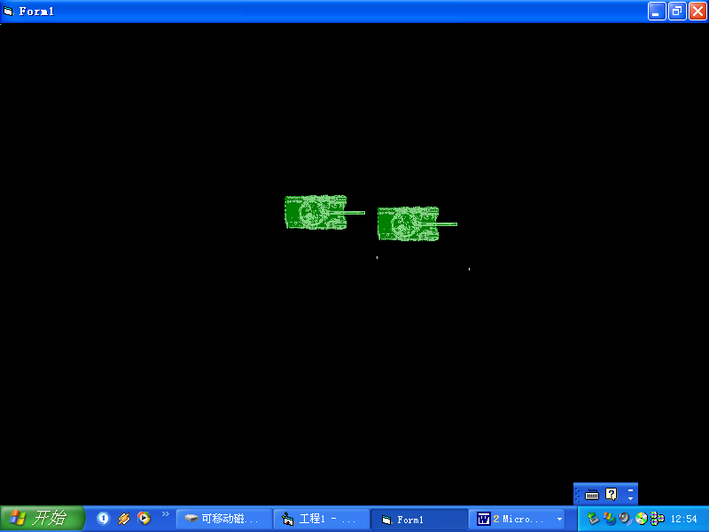
The tanks in facing the same way may be facing up, down left or right.

Once the collision position is set using the tank trajectories we may use it to calculate whether there has been a collision of the tanks

Select Case COLLPOS

Case tank 1 moving left and tank 2 moving down:

x,y
a,b

Test the X co-ordinates for overlap:
If (x < a) AND (x + image width > a)

// this places the X position of one tank overlapping the other

Test the Y co-ordinates for overlap:

if (y>b) AND (y < b + image Width )

// this places the Y position of one tank overlapping the other

if the X and Y co-ordinates overlap then there is a collision and we must move the tanks appropriately:

In this case the X coordinate i.e. the left property is changed, for example:
a = a + 20
x = x - 20

Work out the other possibilities and write the code.

